**Module-6**

**1. What are events in Google analytics?**

An event allows you to measure a specific interaction or occurrence on your website or app. For example, you can use an event to measure when someone loads a page, clicks a link, or completes a purchase, or to measure system behavior, such as when an app crashes or an impression is served.

# Types of events-

* [**Automatically collected events**](https://support.google.com/analytics/answer/9234069) –

[Automatically collected events](https://support.google.com/analytics/answer/9234069) are events that are collected by default when you set up Google Analytics on your website or app.

* [**Enhanced measurement events-**](https://support.google.com/analytics/answer/9216061)

[Enhanced measurement events](https://support.google.com/analytics/answer/9216061) are events that are collected when you set up Google Analytics on your website or app and enhanced measurement is enabled.

You must implement the following types of events in order to see them in Analytics:

* [**Recommended events-**](https://support.google.com/analytics/answer/9267735)

[Recommended events](https://support.google.com/analytics/answer/9267735) are events that you implement, but that have predefined names and parameters. These events unlock existing and future reporting capabilities.

* [**Custom events**-](https://support.google.com/analytics/answer/12229021)

[Custom events](https://support.google.com/analytics/answer/12229021) are events that you define. Make sure you only create custom events when no other events work for your use case. Custom events don't show up in most standard reports so you need to set up custom reports or explorations for meaningful analysis.

**2. Connect your created website and blog to search console, analytics, and google tag manager and add your faculty as user with required permission in it.**

## Google search console-

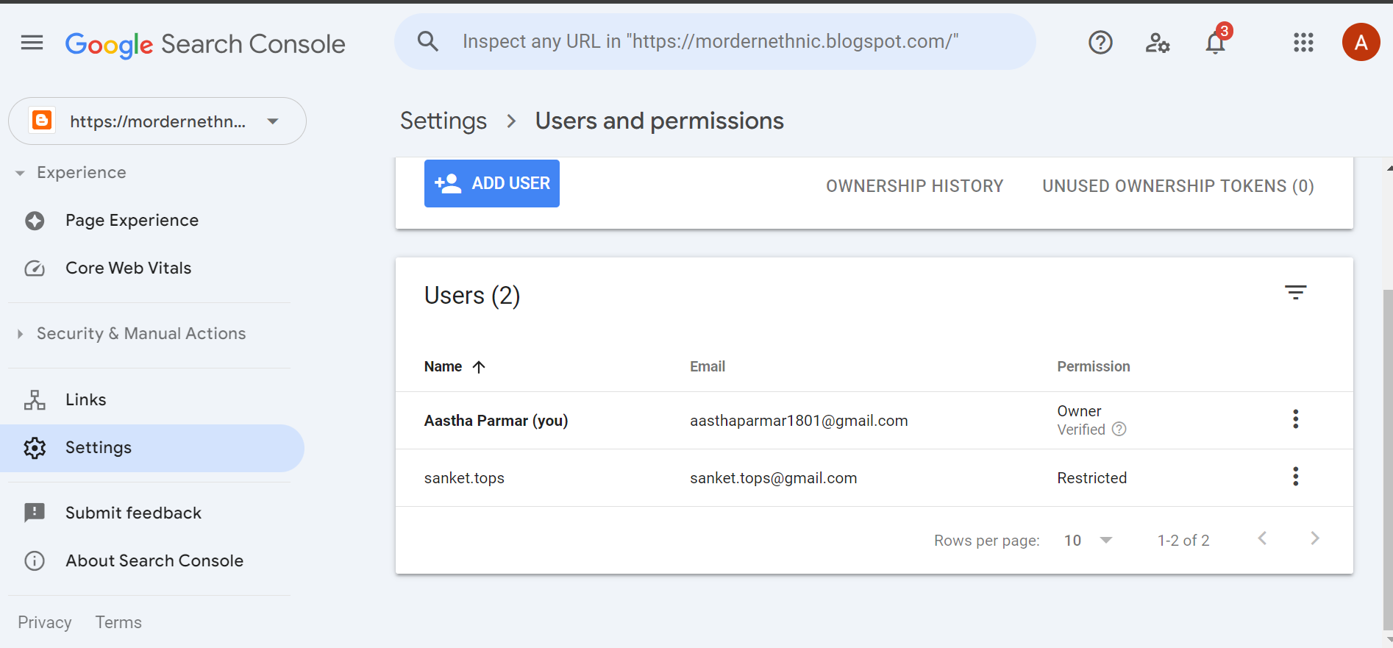

## Google analytics-

## Google tag manager-

1. **Submit the sitemap and robot.txt file in the search console for your website.**

**Sitemap-**

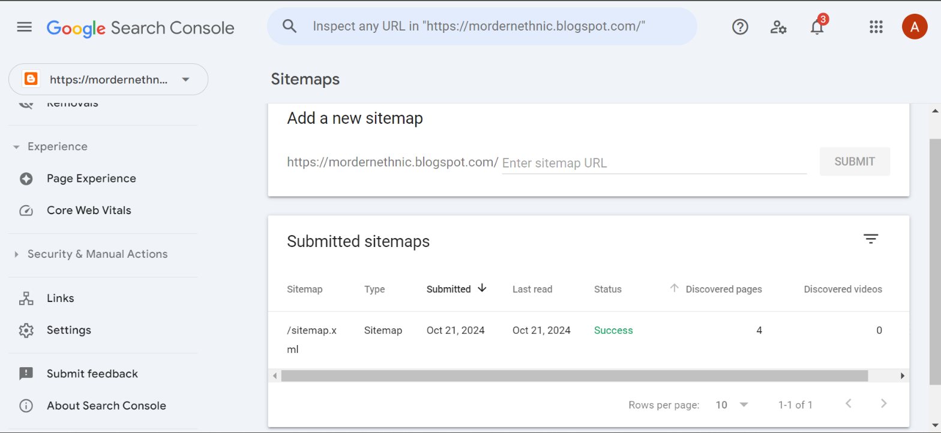

**robot.txt-**

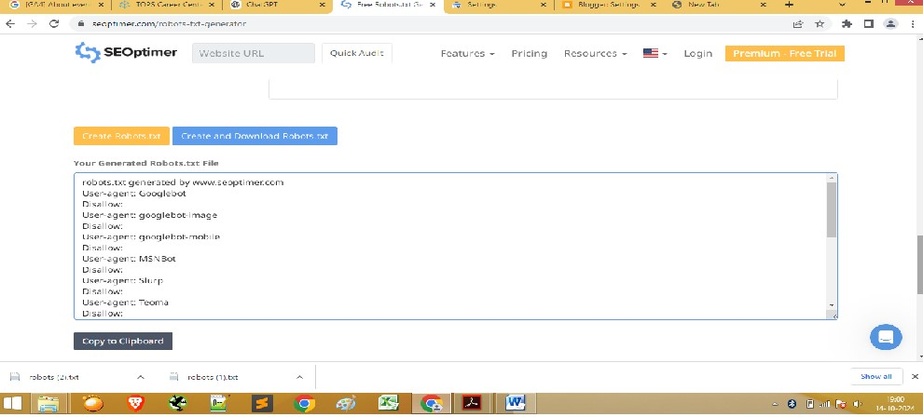

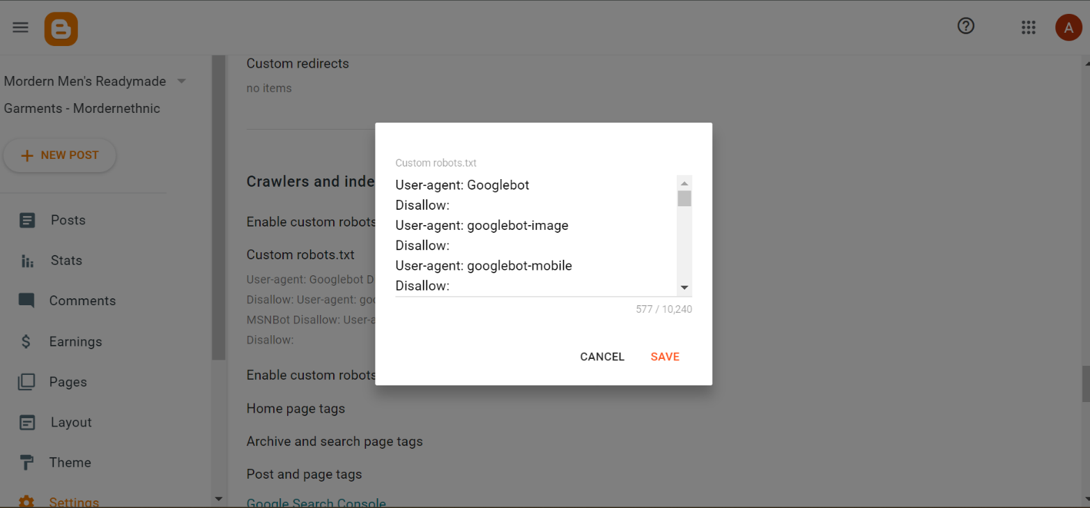

1. **Submit the user flow and traffic source reports for your website.**

1. **Connect your blog to Google Analytics and study the different types of traffic on your site.**

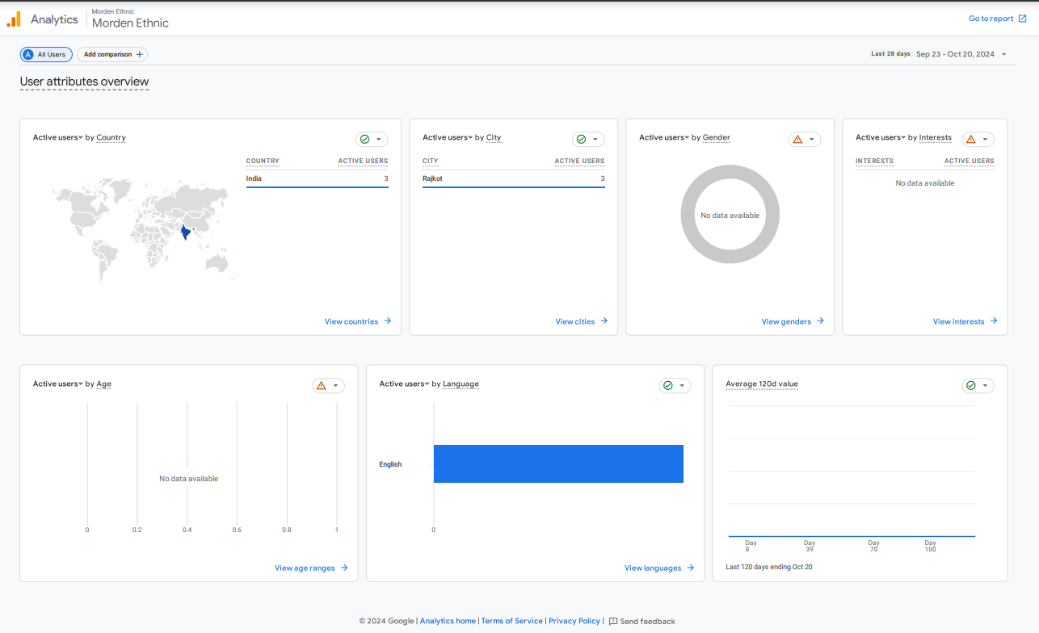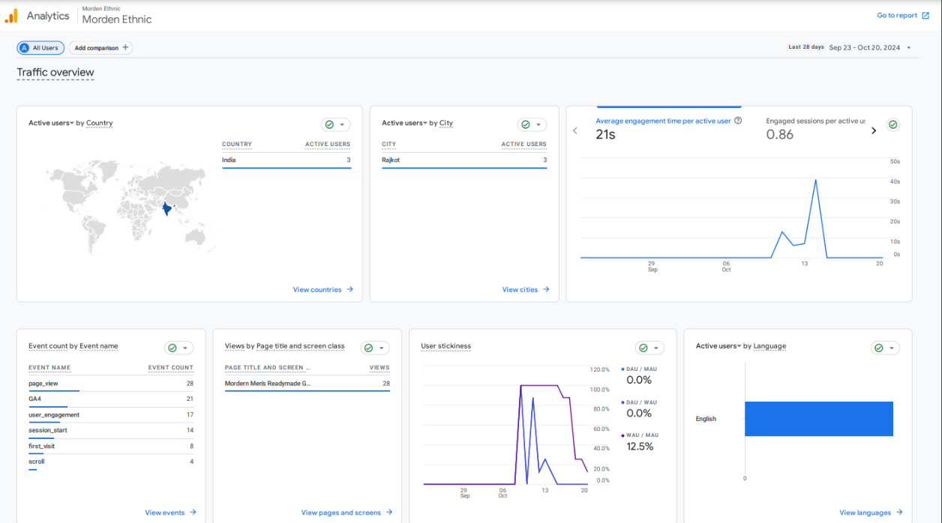

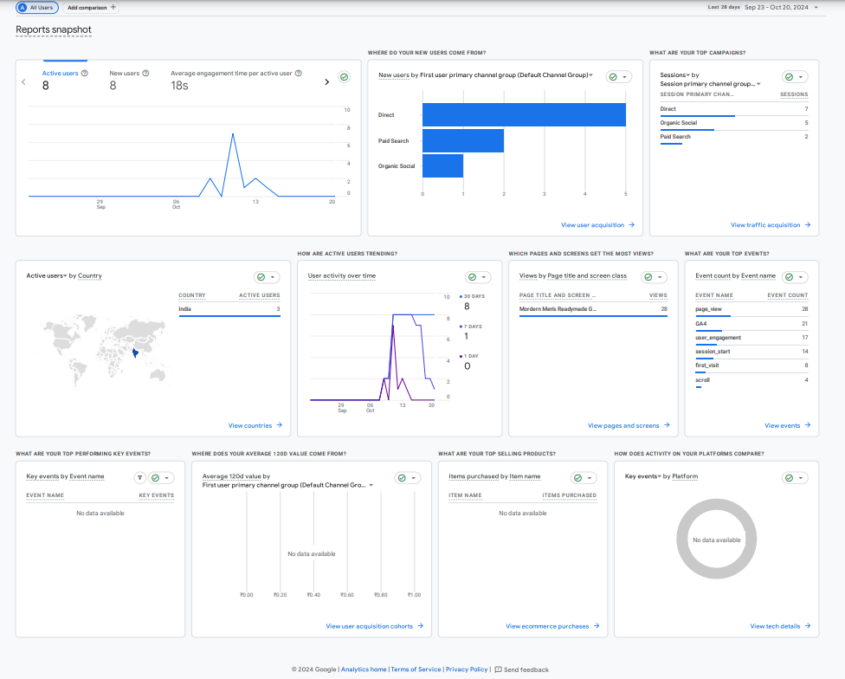

1. **Create a goal for your business and study reports whether it has been completed or not.**

Excel sheet uploaded…..

1. **Track the following interactions in Google tag manager for**

**www.esellerhub.com**

* + **Link clicks**
  + **Page load**
  + **Time (How long a visitor stayed on a particular page )**
  + **Button click**

# Not a owner of this site that’s why I have not a permission of google tag manager — www.esellerhub.com